**Predicting Wire Quality Using Machine Learning**

Team members:

* Naga Preethi Kosuri
* Sailaja Gundam
* Prudhvidhar Reddy Mandla
* Mohammd Iqlas Momin

**Introduction**

In today’s advanced manufacturing landscape, the paramount importance of delivering superior-quality wire products cannot be overstated. It transcends mere technical proficiency and is a cornerstone of any thriving enterprise. With this understanding, we are excited to put forth our proposal that leverages cutting-edge machine-learning methodologies to predict wire quality. This innovative approach is set to revolutionize the manufacturing process, providing us with immediate insights and early warnings about potential quality issues. By harnessing the power of data-driven decision-making, our goal is to enhance efficiency, minimize waste, and set new benchmarks for quality standards in the wire manufacturing sector.

**Goals**

***Predictive Model Development***

The main goal is to develop a machine-learning model that can accurately predict the quality of wire products. The model should be able to identify potential defects, irregularities, and deviations in the manufacturing process that can affect the quality of the final product.

***Improving Manufacturing Efficiency***

This project aims to improve the overall efficiency of the manufacturing process by proactively predicting potential quality issues.This includes reducing waste and downtime, optimizing resource utilization, and improving production planning.

***Ensuring product quality***

This project aims to ensure the highest quality of wire products.

By identifying and resolving quality issues early, you can maintain high product quality standards and increase customer satisfaction and brand reputation.

***Integration into existing processes***

This project aims to seamlessly integrate predictive models into existing manufacturing processes. This includes real-time data collection, analysis, and quality prediction.

***Standards Compliance***

This project aims to ensure that all processes comply with relevant industry standards, data protection regulations, and ethical guidelines. This includes data collection, model development, and real-time integration processes.

***Continuous Improvement***

The project aims to establish a continuous improvement process where the predictive model is regularly updated and fine-tuned based on its performance and feedback from the manufacturing team.

This will help the model adapt to changing manufacturing conditions and continuously improve over time.

**Motivation:**

The motivation behind this project is to improve the quality control process in wire manufacturing. Accurately predicting wire quality is important to ensure product integrity, reduce waste, and improve overall efficiency. By using machine learning techniques, we aim to create robust predictive models that can predict potential cable quality issues and take timely corrective actions. This project is based on the need to optimize manufacturing processes, minimize production costs, and maintain high standards of product quality. Successful implementation of this project could lead to significant improvements in operational efficiency and customer satisfaction.

**Significance:**

The importance of this project lies in its potential to revolutionize the quality control process in wire manufacturing. Using machine learning techniques, you can automate the process of quality prediction and reduce reliance on manual inspection and the human errors that come with it. This can lead to more consistent product quality, higher customer satisfaction, and increased competitiveness in the market. Additionally, the insights gained from this project can be applied to other manufacturing processes, paving the way for broader applications of machine learning in the manufacturing industry.

**Objectives:**

Our main task is to develop a machine-learning model that can predict the quality of wires. Identify potential defects, irregularities, or deviations in wire manufacturing that can affect the quality of the final product. Additionally, our goal is to seamlessly integrate this model into existing manufacturing processes to enable real-time quality prediction and timely corrective actions. Ultimately, we strive to establish a data-driven quality control process that can adapt to changing manufacturing conditions and continuously improve over time.

**Features**

The dataset features are:

***Temperature (°C):***This represents the temperature conditions during the wire manufacturing process.

Temperature determines the properties of the wire. Its strength and flexibility have a great impact.

***Tension (N/m²)****:*Indicates the tension applied to the wire during manufacturing.

The level of tension can affect the dimensional stability and surface quality of the wire.

***Diameter (MM):***This is the diameter of the wire.

**Related research (background):**

In recent years, machine learning has been increasingly used for quality control and predictive maintenance in the manufacturing industry. Several studies have demonstrated the effectiveness of machine learning techniques in predicting product quality and identifying potential defects in manufacturing processes.

**Dataset:**

The dataset used is "synthetic_wire_quality_dataset.csv".

This dataset contains information collected from sensors and machines during the wire manufacturing process. Characteristics of this dataset include temperature, voltage, diameter, and wire quality.

**Detailed draft method:**

***Data collection:*** Data was collected from sensors and machines involved in the wire manufacturing process. This data includes measurements such as temperature, voltage, and diameter.

***Data Preprocessing:***

We cleaned the data by handling missing values and outliers.

We also transformed the data into a suitable format for machine learning.

***Feature Engineering:*** We identified and selected relevant features that can influence wire quality. These features include temperature, tension, and diameter.

Model Selection: We chose appropriate machine learning algorithms such as SVM, KNN, Random Forest, and Naive Bayes. These algorithms were chosen for their ability to handle complex patterns and relationships in the data.

***Training and testing:*** We split the dataset into a training set and a test set. The model was trained on the training set and its performance was evaluated on the test set.

***Real-time integration:*** The model was implemented into the manufacturing process to provide real-time predictions. This allows you to identify potential quality issues early and take corrective action.

***Analysis***

We thoroughly analyzed the data and model performance.

You checked for correlations between features, used the Describe function to get a statistical overview of your data, created histograms to visualize the distribution of your data, and checked for outliers.

***Implementation***

The model is implemented in the manufacturing process.

Continuously monitors data from sensors and machinery to predict cable quality and send alerts when potential quality issues are detected.

***Preliminary results***

Preliminary results show that the model can predict wire quality with high accuracy. This allowed us to identify potential quality issues early and take corrective action, increasing the overall efficiency of our manufacturing process.

**Project Management**

Effective project management is essential to the success of a project. We have assembled a dedicated team with clearly defined roles and responsibilities.

***Member 1:*** Preethi is responsible for data collection, preprocessing. This ensures that your data is clean, relevant, and ready for analysis and built the Random Forest model.

Also, identify and select the characteristics that are most likely to affect cable quality, and responsible for model selection random forest.

**Fig 1: Dataset**

**Fig 2: Checking and handling missing values**

**Fig 3: Checking and handling missing values**

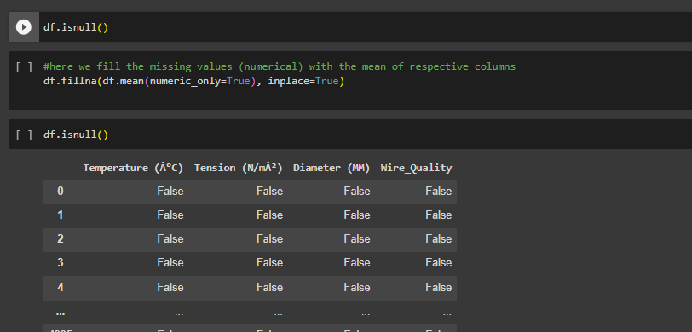

Fig 4: Random Forest model metrics

***Member 2:*** Prudhvidhar is responsible for feature analysis like data transformation, plotting (box plot, histogram, correlation matrix) and KNN.

For our statistical analysis on the data, we used the describe() method and got the results below:  
**Fig 5: Statistical analysis**

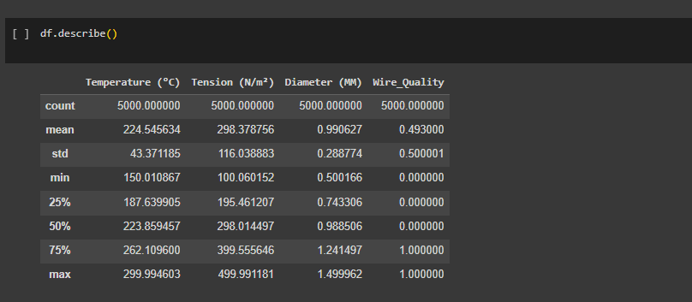

**Fig 6: Plot showing the distribution of data of each feature**

**Fig 7: Plotting the graph to compare the features**

Fig 8: K-Nearest Neighbors metrics

***Member 3:*** Sailaja is responsible for modeling Support vector machine, training, and testing. Worked on checking for outliers and transforming the data using minmax scaler.

She selected the best machine learning algorithm for our task and made sure the model is thoroughly trained and tested.

The figures below show the metrics calculation results of each model:

**Fig 9: Checking for outliers**

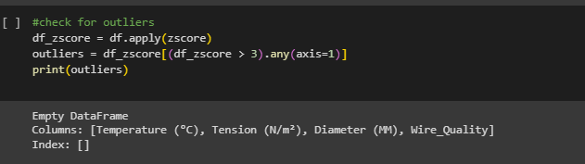

Fig 10: Data transformation using MinMaxScaler

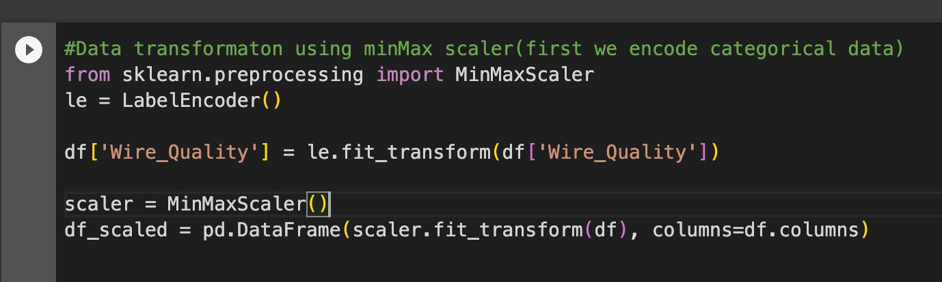

Fig 11: Box plot to show outliers

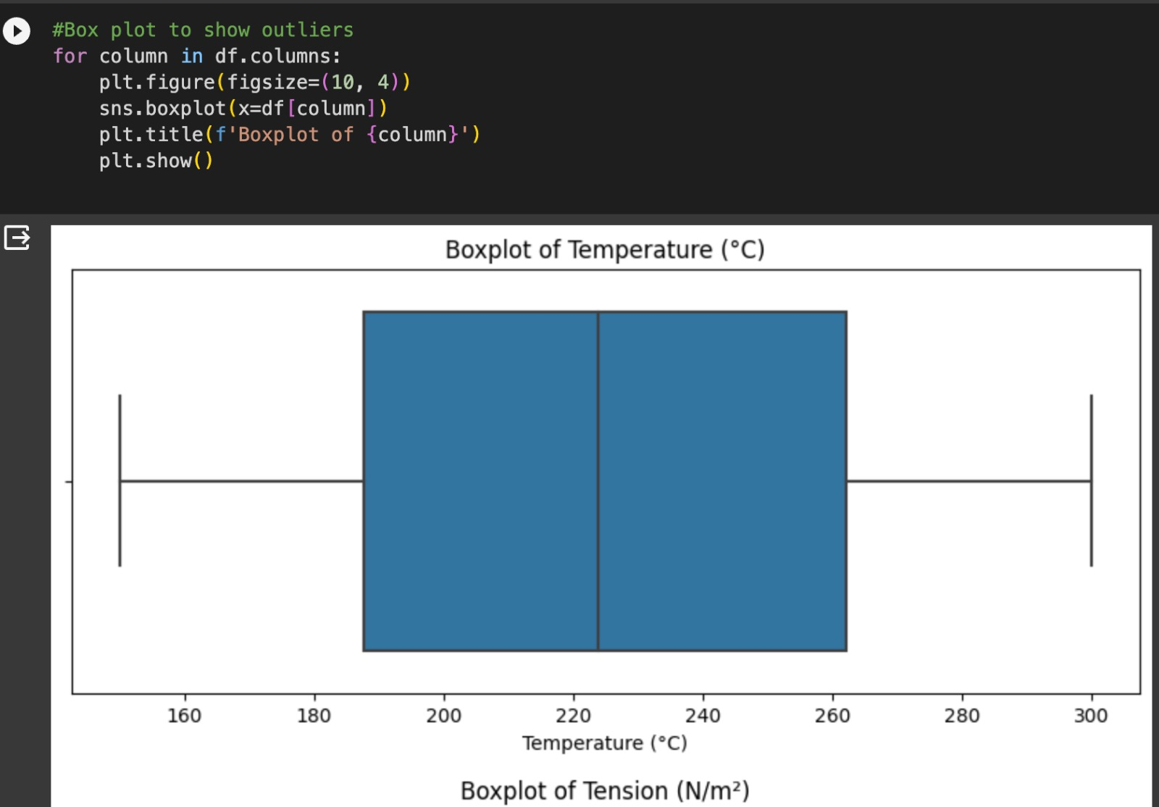

Fig 12: Box plot to show outliers

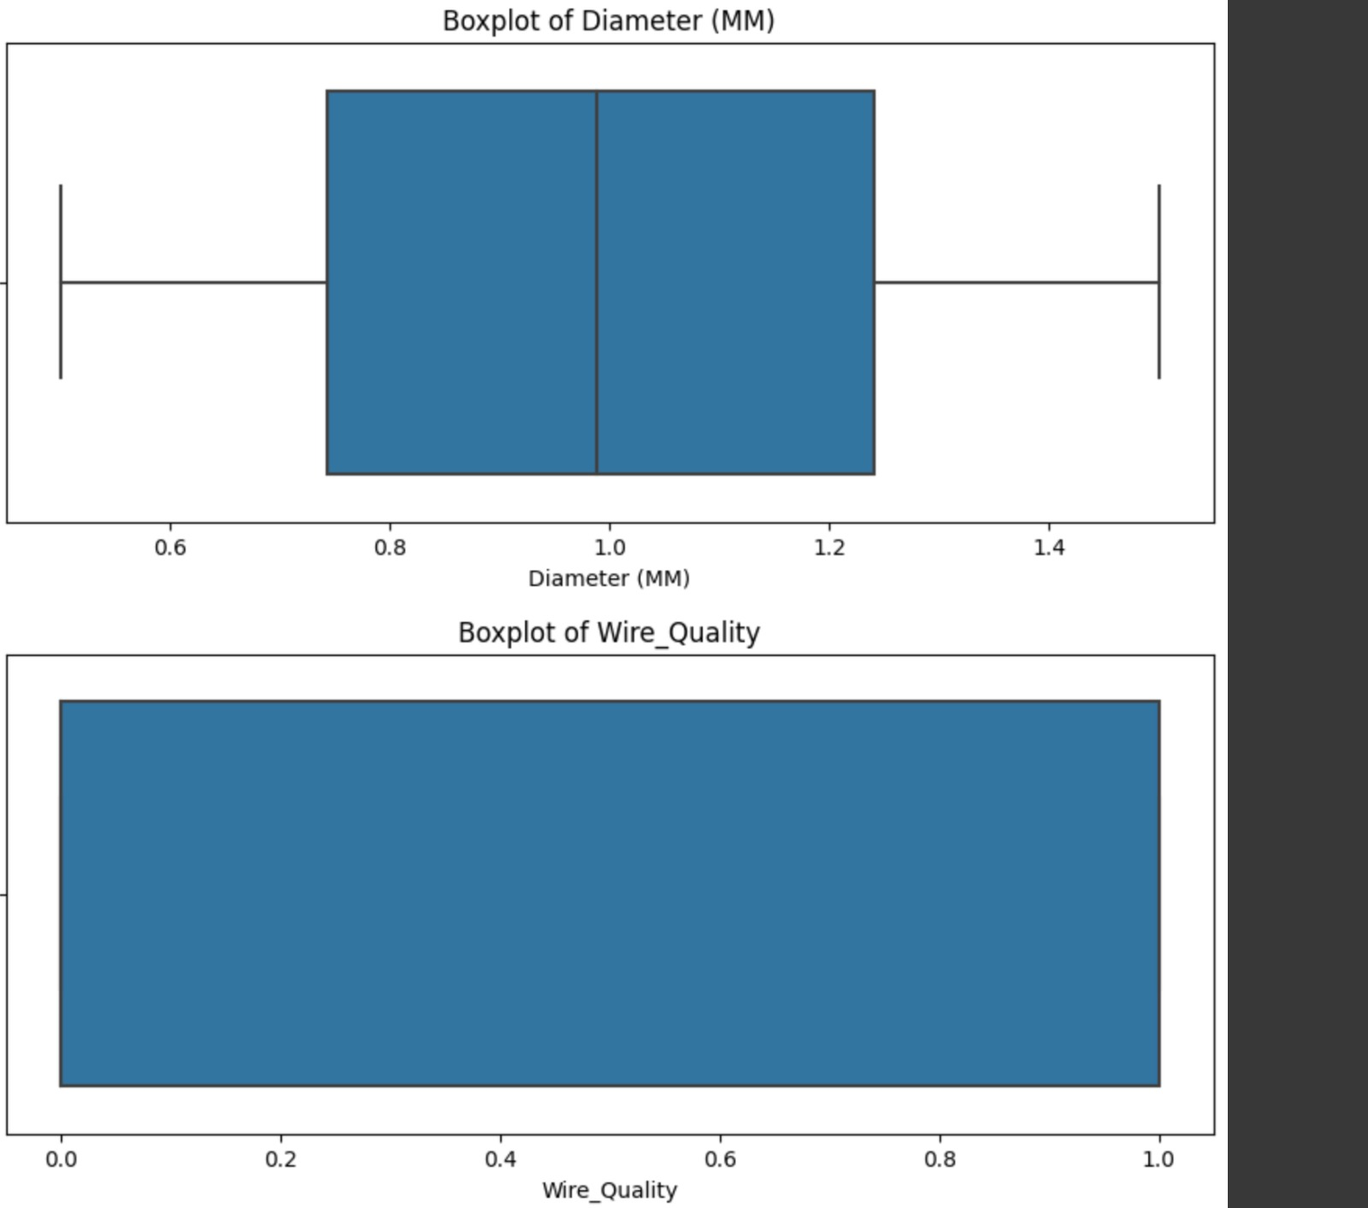

**Fig 13: SVM model metrics**

***Member 4:*** Mohammd Iqlas is responsible for model selection Naïve Bayes model training, and testing.

He proposed the appropriate machine learning algorithm for our task and made sure the model is thoroughly trained and tested.

**Fig 14: Correlation analysis**

The results of the correlation analysis are as shown in the figure below:

Fig 15: Naïve Bayes metrics

**Work to be Completed**:

***Graphs with decision boundaries:*** For the proposed models we need visualizing the graphs with decision boundaries.

***Real-time Integration:*** We are currently working on integrating the model into the manufacturing process for real-time predictions. This will involve fine-tuning the model based on its performance and feedback from the manufacturing team.

***Compliance Check:*** We will ensure that the data collection, model development, and real-time integration processes comply with relevant industry standards, data privacy regulations, and ethical guidelines.

**Issues/Concerns:**

We need to ensure that the real-time integration of the model does not disrupt the existing manufacturing process. We need to continuously monitor the model’s performance and make adjustments as necessary. Additionally we hold regular team meetings to discuss project progress, address issues and concerns, and make decisions together. Also, we used project management tools to track tasks, deadlines, and milestones. This helped us stay organized, manage our time effectively, and ensure project goals were met on time.

**References**

1. Zhimin Guo, Chao Wang, Yangyang Tian, Xiaowei Gao, Qiyun Tan, Xiaofei Zhang, and Shaoguang Yuan. 2022. Application of machine learning in wire damage detection for safety procedure. *Soft Computing* 26, 20: 10623–10631. https://doi.org/10.1007/s00500-022-06747-z

2. Gonçalo San-Payo, João Ferreira, Pedro Santos, and Ana Martins. 2019. Machine learning for quality control system. *Journal of Ambient Intelligence and Humanized Computing* 11, 11: 4491–4500. https://doi.org/10.1007/s12652-019-01640-4

3. Hasan Tercan and Tobias Meisen. 2022. Machine learning and deep learning based predictive quality in manufacturing: a systematic review. *Journal of Intelligent Manufacturing* 33, 7: 1879–1905. <https://doi.org/10.1007/s10845-022-01963-8>

4. Sidharth K Sankhye and Guiping Hu. 2020. Machine learning methods for quality prediction in production. *Logistics* 4, 4: 35. https://doi.org/10.3390/logistics4040035